INSTALL ANACONDA

# TEAM_ID: PNT2022TMID50401

**Anaconda** is a distribution of the Python and R programming languages for scientific computing, that aims to simplify package management and deployment. The distribution includes data-science packages suitable for Windows, Linux, and macOS. It is developed and maintained by Anaconda. which was founded by Peter Wang and Travis Oliphant in 2012 As an Anaconda, it is also known as **Anaconda Distribution** or **Anaconda Individual Edition**, while other products from the company are Anaconda Team Edition and Anaconda Enterprise Edition, both of which are not free.

WAY TO INSTALL ANACONDA

**STEP 1: Download and Anaconda.**

**STEP 2: Install the Anaconda.**

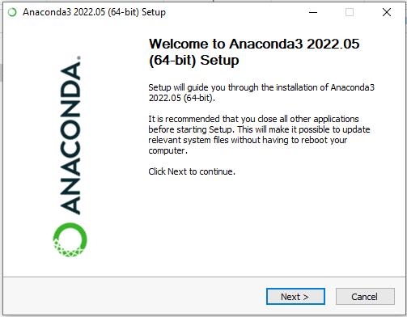

**STEP 3: Click I Agree.**

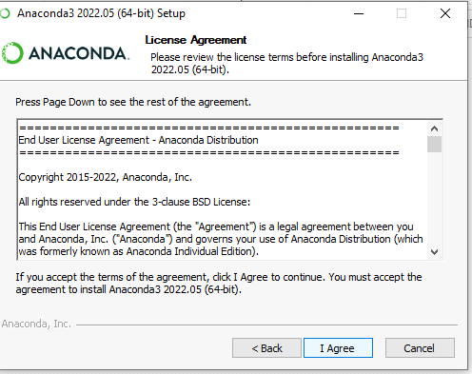

**STEP 4: Choose the Installation Location.**

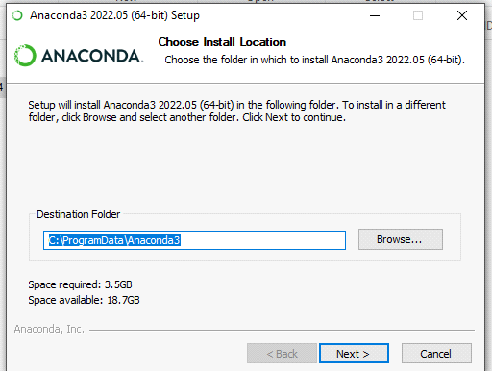

**STEP 5: Installing the Requiring packages.**

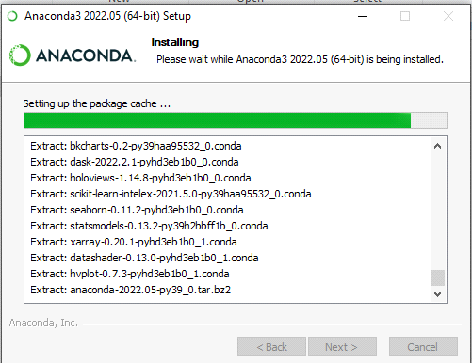

**STEP 6: Setting up the base environment.**

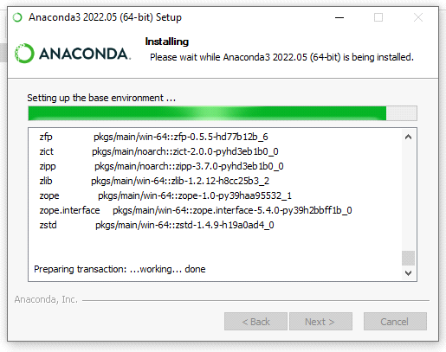

**STEP 7: Succesfully Installed and check the Anacoda Navigator working or not.**

